

ISFS622: Quantum Computing in Financial Services

Assignment 2: Technical Specification Template (Group)

Topic: Quantum-Assisted Multi-Asset Portfolio Optimisation – Cardinality-Constrained Mean-Variance Asset Selection with QAOA
Student Names: Justin Ng, Phua Zai Wei, Pek Ling Hong, Sreeraj Kaucek Arunkumar

Contents
1. Technical Solution Overview 3
High-level system architecture 3
2. Quantum algorithms 3
Step 1 – Mean-variance problem formulation 3
Step 2 – QUBO and Ising mapping 4
Step 3 – QAOA 4
The quantum circuit 4
Error correction, mitigation and hardware 6
3. Quantum Advantages 6
Backtest methodology 6
Performance metrics – definitions 6
Solution quality: QAOA vs the exact optimum 7
Results 7
What each engine chose 9
Why quantum is the right long-term solution 9
4. Commercial Cost and Benefits 10
Total cost of ownership (indicative) 10
Benefits 11
Break-even and cost-benefit assessment 11
5. Risks and Challenges 11
Technical and implementation risks 11
Model stability and robustness 12
Risk to clients 12
6. Conclusion 13
References 14

Technical Solution Overview
This solution automates tactical asset allocation: every month it selects a diversified sub-portfolio from a multi-asset ETF universe. From eight ETFs spanning the major asset classes, the engine chooses exactly four assets to hold (equal-weighted) until the next rebalance. Choosing B assets from N is a cardinality-constrained combinatorial optimisation – the class of problem the quantum algorithm targets.
Ticker | Exposure | Ticker | Exposure
SPY | US large-cap equity | LQD | Investment-grade credit
QQQ | US growth / technology | TLT | Long-dated Treasuries
EFA | Developed intl. equity | GLD | Gold
EEM | Emerging-market equity | DBC | Broad commodities
Business-case link: as the investable universe and the number of real-world constraints grow, the count of candidate portfolios explodes and classical optimisers struggle. The goal is better risk-adjusted returns and the ability to optimise large, constraint-rich portfolios that are intractable for exact classical methods. The proof of concept (PoC) implements the full pipeline and benchmarks the quantum engine against a classical machine-learning challenger and two passive benchmarks over roughly ten years of monthly data.

High-level system architecture
• Data layer (portfolio_utils.py): downloads and caches monthly total-return series for the eight ETFs and computes the performance metrics.
• Model layer: at each rebalance a trailing 36-month window estimates the expected-return vector μ and covariance matrix Σ, which define the optimisation problem.
• Quantum solver (quantum_portfolio_qaoa.py): the problem is mapped to a QUBO / Ising Hamiltonian and solved with QAOA; a classical optimiser (COBYLA) tunes the circuit parameters in a hybrid loop, and a classical exact eigensolver validates every solution.
• Application layer (comparison.ipynb): holds the selected assets, rolls the walk-forward backtest and compares all strategies. Only the solver call uses quantum hardware, so the architecture is unchanged at scale.

Quantum algorithms

Step 1 – Mean-variance problem formulation
Each asset i carries a binary decision variable xᵢ ∈ {0,1} (1 if the asset is held). The monthly decision minimises a mean-variance objective subject to a cardinality (budget) constraint:
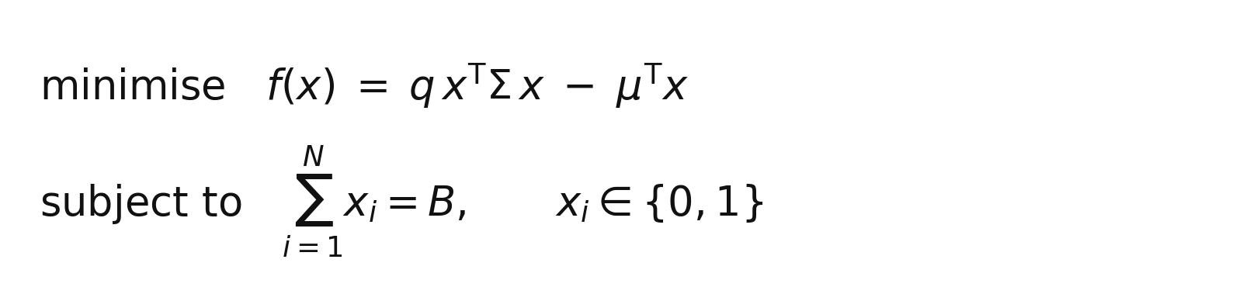
Figure 1. The asset-selection objective and budget constraint.
Symbols: μ is the vector of expected (mean) monthly returns and Σ the return covariance matrix, both estimated over the trailing 36-month window; q is the risk-aversion coefficient (q = 1.0); and B = 4 is the number of assets to hold. The term −μᵀx rewards expected return, while q·xᵀΣx penalises portfolio variance and rewards diversification through the off-diagonal covariances.

Step 2 – QUBO and Ising mapping
The equality constraint is folded into the objective as a quadratic penalty (weight λ), giving an unconstrained binary problem (a QUBO). Substituting xᵢ = (1 − Zᵢ)/2 maps the QUBO onto an Ising cost Hamiltonian H_C whose ground state encodes the optimal portfolio:
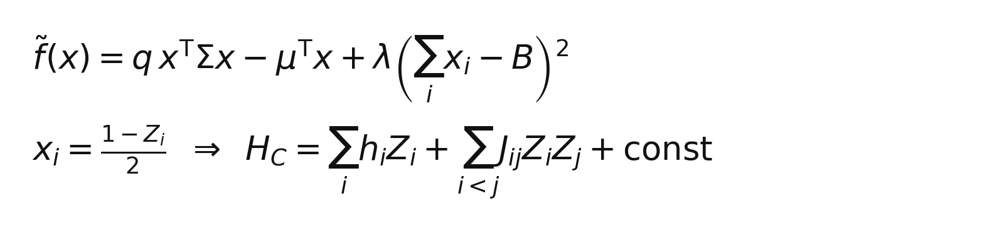
Figure 2. Penalised QUBO and its mapping to an Ising Hamiltonian.
Here Zᵢ is the Pauli-Z operator on qubit i, hᵢ are the local fields (from the linear −μ and penalty terms) and Jᵢⱼ are the pairwise couplings (from Σ and the penalty). Because the covariance matrix is dense, every asset pair couples – giving a fully connected interaction graph.

Step 3 – QAOA
QAOA is a hybrid quantum-classical variational algorithm. Starting from a uniform superposition, it applies p alternating layers of a cost unitary U_C(γ) and a mixer unitary U_M(β); a classical optimiser tunes (γ, β) to minimise the measured energy:
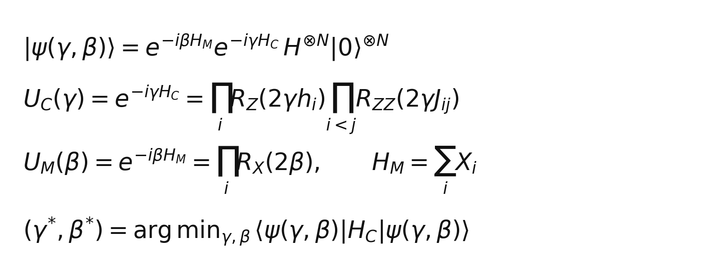
Figure 3. The QAOA ansatz state, its cost / mixer unitaries and the classical objective.
U_C applies a Z-rotation R_Z(2γhᵢ) per qubit and a two-qubit R_ZZ(2γJᵢⱼ) per coupled pair; U_M applies an X-rotation R_X(2β) per qubit. The PoC uses p = 1 (one layer), 1024 measurement shots and COBYLA (max 80 iterations) with a seeded initial point for reproducibility. After convergence the most probable bitstring is decoded into the selected assets.

The quantum circuit
With eight ETFs the circuit uses eight qubits. Figure 4 is the actual p = 1 QAOA circuit generated for one rebalance: a Hadamard layer (drawn as U(π/2,0,π)) creates the uniform superposition; the cost layer applies eight R_Z rotations (each labelled with its real hᵢ coefficient) and 28 R_ZZ couplings (labelled with γ); and the mixer layer applies eight R_X(2β) rotations. The two free parameters are γ and β.
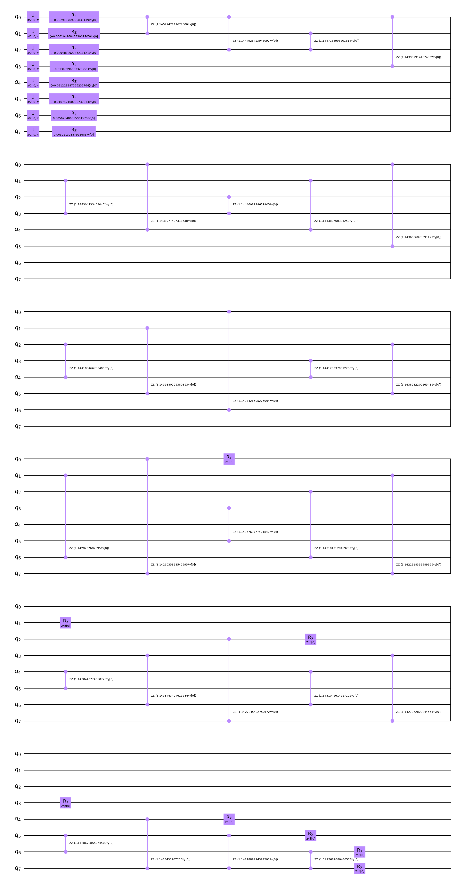
Figure 4. The actual 8-qubit, p = 1 QAOA circuit for one monthly rebalance (Hadamard layer → R_Z / R_ZZ cost layer → R_X mixer).
Circuit property | Value
Qubits | 8
Hadamard gates (superposition) | 8
R_Z rotations (linear / local fields) | 8
R_ZZ couplings (quadratic = C(8,2)) | 28
R_X rotations (mixer) | 8
Variational parameters (γ, β) | 2
Gate-level depth | 16
The 28 R_ZZ couplings equal C(8,2) = 28 – one for every asset pair – because the covariance matrix is fully dense. R_ZZ is not a native hardware gate; it is compiled from two CNOTs and one R_Z, as shown below. This is why dense couplings drive the two-qubit gate count and circuit depth, and why hardware connectivity matters at scale.
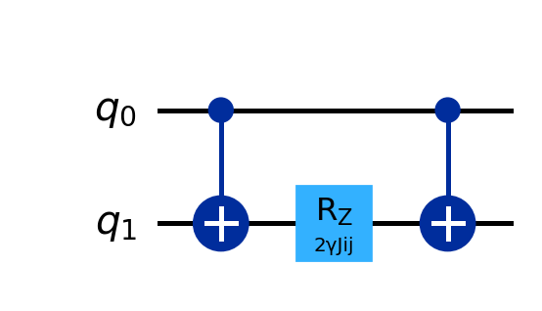
Figure 5. An R_ZZ(2γJᵢⱼ) coupling compiled into CNOT – R_Z – CNOT.

Error correction, mitigation and hardware
The PoC runs on a noiseless state-vector simulator, so results are exact. On real NISQ hardware, two-qubit gate errors (~10⁻³), readout errors (~10⁻²) and decoherence corrupt the measured energies. Near term, error mitigation (measurement-error mitigation, zero-noise extrapolation, dynamical decoupling) suffices for this shallow eight-qubit circuit. Long term, quantum error correction (surface codes, ~1000 physical qubits per logical qubit) is required as the universe and circuit depth grow. Hardware: the PoC needs only a workstation and simulator; near-term production uses cloud NISQ QPUs (superconducting IBM Heron, or trapped-ion IonQ / Quantinuum whose all-to-all connectivity suits the dense coupling graph); large, constrained portfolios are the long-term fault-tolerant target.

Quantum Advantages

Backtest methodology
All strategies run through one walk-forward backtest: a 36-month trailing window, quarterly rebalancing, and 82 out-of-sample months. There is no look-ahead – each decision uses only past data. Both engines obey the same rule (hold 4 of 8, equal-weighted), so the comparison isolates the selection method. The classical challenger is a Random Forest that predicts each asset's next-month return from momentum and volatility features and holds the top four.

Performance metrics – definitions
Metrics are computed from the monthly strategy returns rₜ (r̄ = mean, σ_r = standard deviation, P = 12 periods/year):
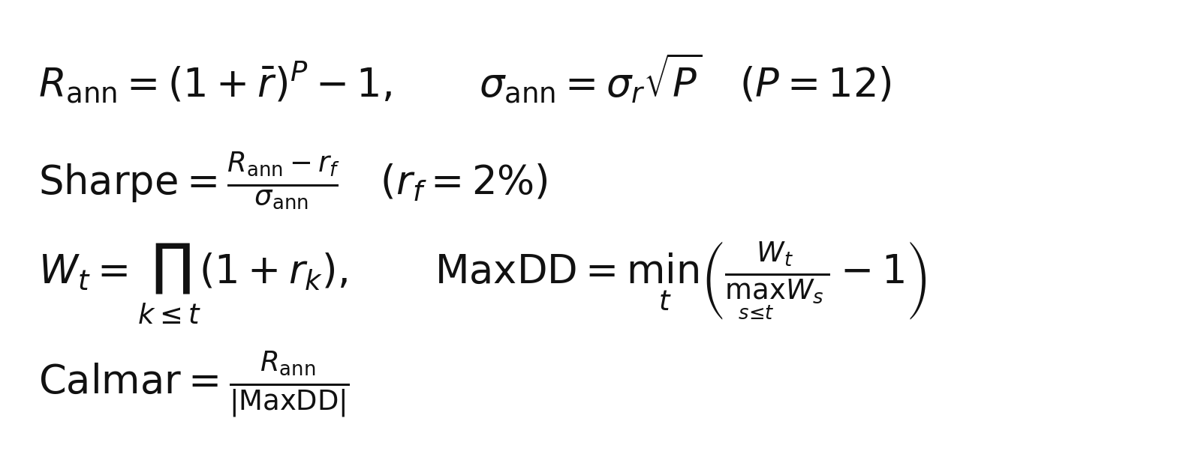
Figure 6. Definitions of the performance metrics.
• Annualised return R_ann compounds the mean monthly return to a yearly figure.
• Annualised volatility σ_ann scales the monthly standard deviation by √P.
• Sharpe ratio = excess return over volatility (risk-free rate r_f = 2%); the headline risk-adjusted measure.
• Maximum drawdown (MaxDD) is the worst peak-to-trough fall of the cumulative wealth curve Wₜ.
• Calmar ratio = annualised return divided by the absolute maximum drawdown.

Solution quality: QAOA vs the exact optimum
Because eight qubits is small, a classical exact eigensolver finds the true optimum and serves as ground truth. Across all 28 rebalances the QAOA circuit reproduced the exact optimal asset subset every time (match rate = 1.00, mean optimality gap = 0.0), validating the QUBO mapping, the circuit and the optimisation loop.

Results
Strategy | Ann. Return | Ann. Vol | Sharpe | Max Drawdown | Calmar
QAOA Quantum | 9.8% | 11.3% | 0.69 | -20.5% | 0.48
Classical ML (Random Forest) | 8.5% | 14.2% | 0.46 | -17.7% | 0.48
Static 60/40 | 8.7% | 12.9% | 0.52 | -26.2% | 0.33
Equal-Weight | 7.9% | 11.5% | 0.51 | -20.3% | 0.39

The quantum-selected portfolio earns the highest Sharpe ratio (0.69) and the highest return at the lowest-but-one volatility, beating the ML challenger (0.46) and both passive benchmarks (0.52 / 0.51). The charts below show the growth of $1, the drawdown profile and the metric comparison.
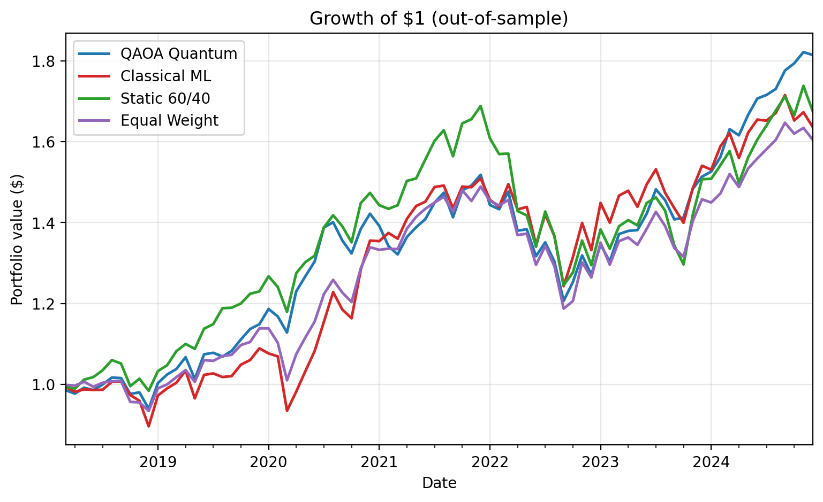
Figure 7. Out-of-sample growth of $1.
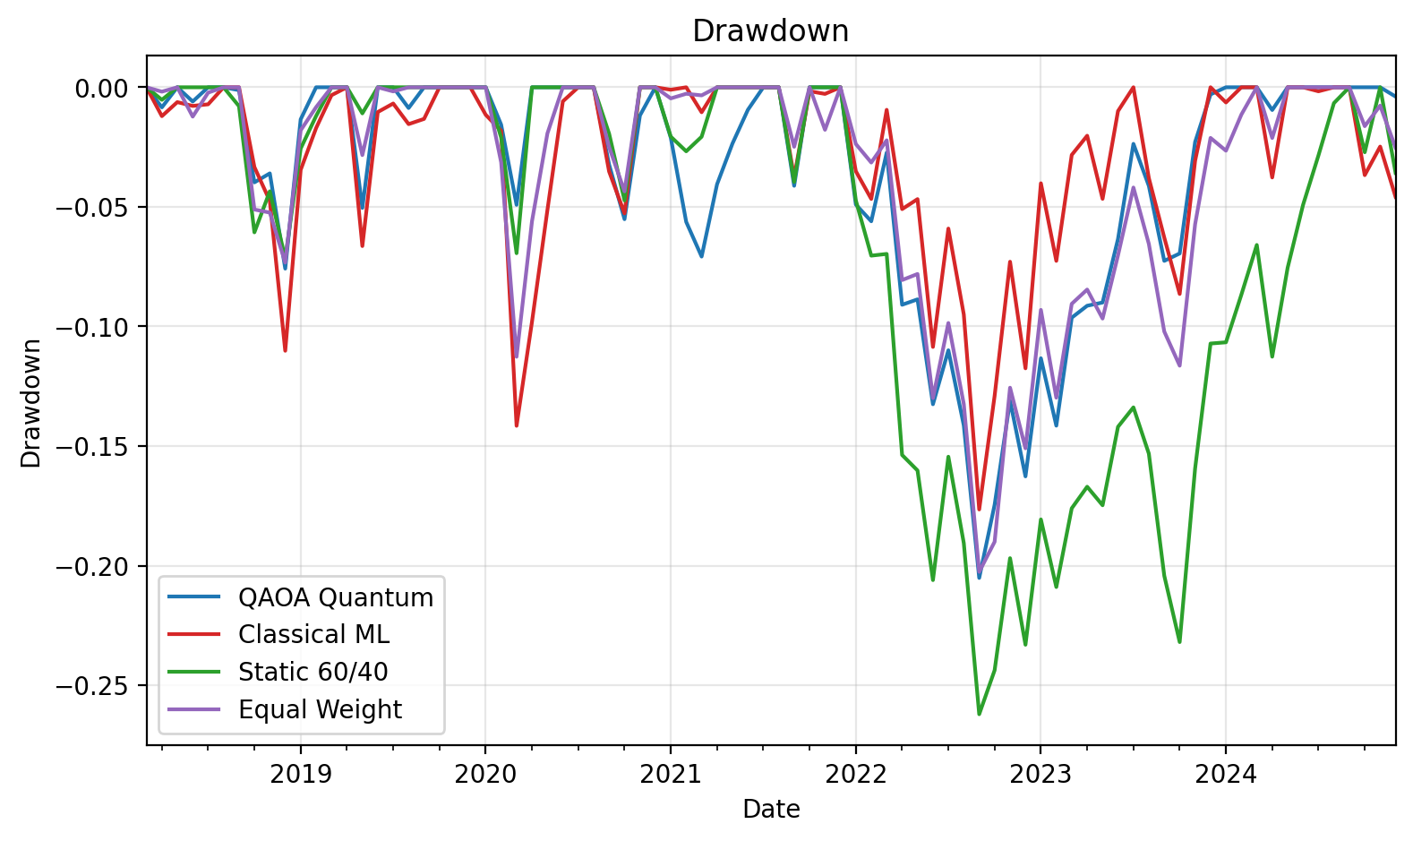
Figure 8. Drawdown profile (quantum has the shallowest deep-drawdowns of the active strategies).
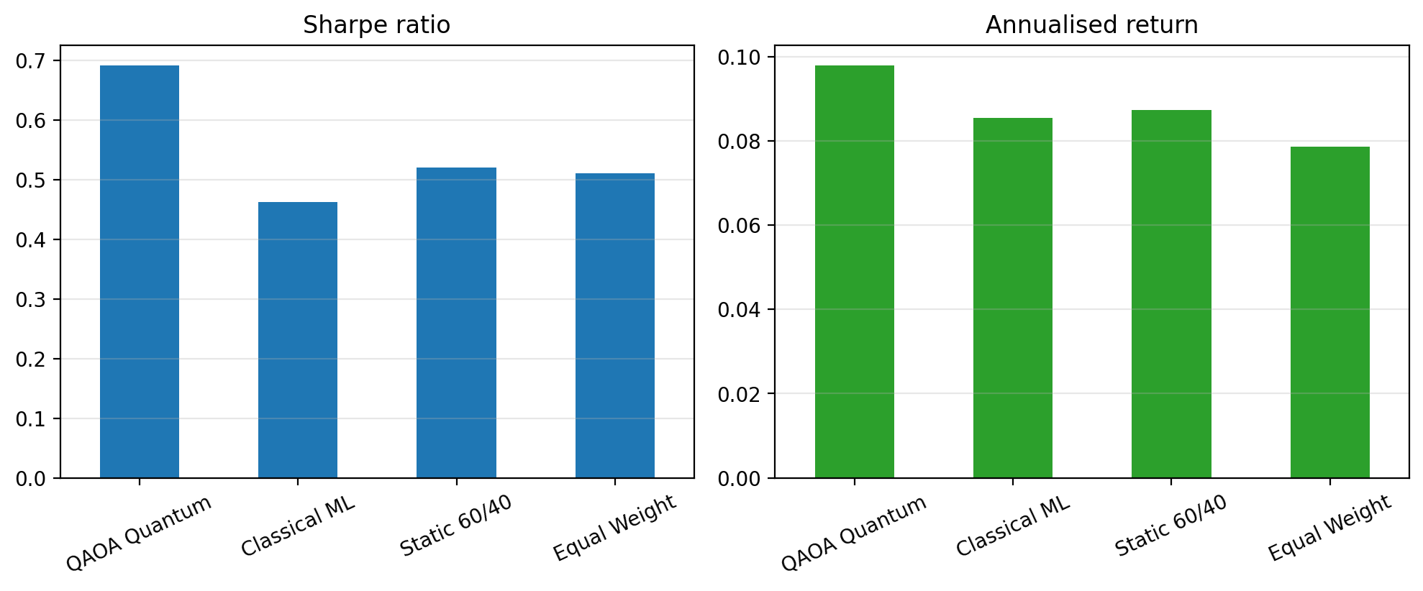
Figure 9. Sharpe ratio and annualised return by strategy.

What each engine chose
The quantum optimiser and the ML predictor express different 'personalities' – Figure 10 shows how often each asset was held. The mean-variance QAOA favours diversifying, lower-correlation assets, whereas the return-chasing Random Forest concentrates differently.
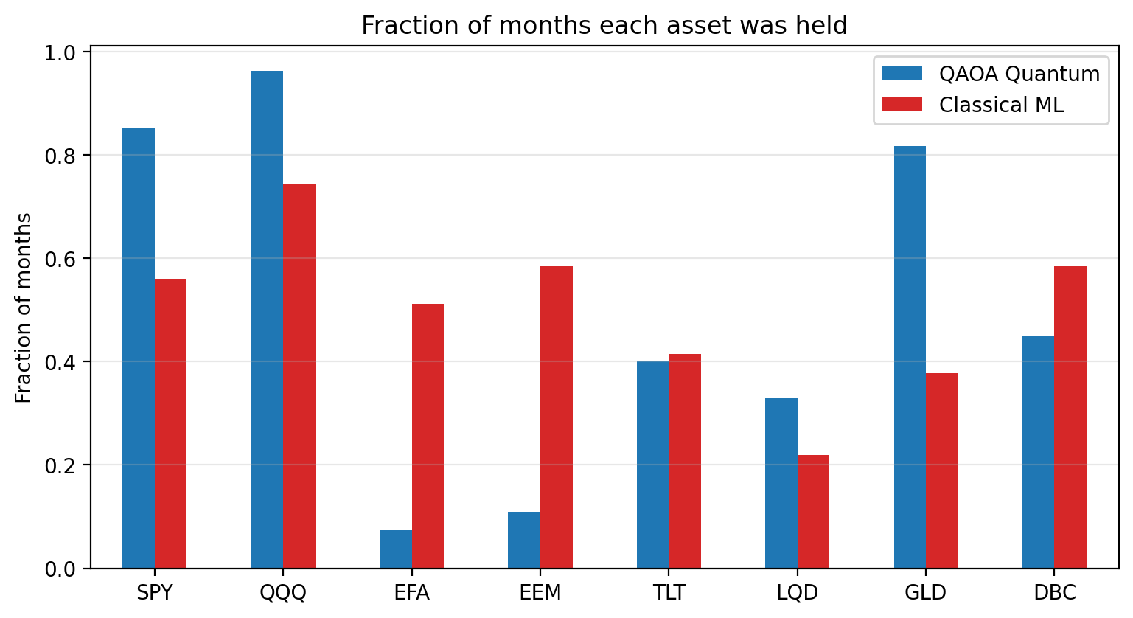
Figure 10. Fraction of months each asset was held.

Why quantum is the right long-term solution
The decisive advantage is in scaling. Selecting B of N assets has C(N, B) combinations – for example C(500, 30) ≈ 10⁴⁸ – and adding realistic constraints (sector caps, cardinality, lot sizes, transaction costs) makes the problem NP-hard, beyond exact classical solvers. QAOA and quantum annealing explore this space with only N qubits (linear in assets), offering a credible route to high-quality solutions where classical heuristics degrade. The PoC demonstrates the complete, validated workflow that extends directly to that regime.

Commercial Cost and Benefits
The cost profile is modest at PoC scale, but it is dominated by people and integration, not quantum compute. The figures below are indicative planning ranges (fully-loaded, US$) for a single-desk deployment inside an existing asset manager; they are order-of-magnitude, not quotes, and would be firmed up in a costed pilot.

Total cost of ownership (indicative)
Item | One-off | Annual run | Basis / notes
Quantum compute (cloud QPU) | – | ~$2k–$5k | A single 8-qubit rebalance solves in seconds. Premium superconducting QPU time is priced on a per-second basis (order of US$1.60/sec, ~US$96/min) [10]; a handful of jobs per rebalance over ~12 rebalances/yr is minor. The state-vector simulator is effectively free at N = 8. QPU cost scales with shots x circuit depth x jobs, so it grows with the universe, not linearly with AUM.
Development (build & validate) | ~$0.5m–$1.5m | – | 2–4 FTE (quant researcher + quantum-software engineer + data/infra support) over ~6–12 months to build, validate and integrate the solver. Specialist quantum-finance engineers are scarce and carry a salary premium [4,5].
Data feeds & classical infrastructure | Low | Low–Moderate | Market-data subscriptions and standard compute, largely reused from existing systems; incremental cost is small.
Talent, training & governance | Moderate | Moderate | Upskilling the quant team, plus model-risk, compliance and audit overhead that any client-facing model attracts.

Indicative all-in Year-1 cost is therefore on the order of US$1m–US$2m, roughly 90% of which is headcount; quantum compute is a rounding error at this scale. Ongoing run-rate (compute + maintenance + a partial team) is order US$0.3m–US$0.6m/yr.

Benefits
Benefits fall into financial and strategic categories:
• Higher risk-adjusted return (gross, backtested): the quantum strategy earned 9.8% per year versus 8.7% for 60/40 at lower volatility (Sharpe 0.69 vs 0.52). These figures are gross of transaction costs, taxes and slippage, which are not modelled and would reduce the live net edge.
• Scalability to large, constrained universes that classical exact optimisers handle poorly [4,5,9] – the capability that justifies the investment as mandates and constraint sets grow.
• Strategic differentiation and intellectual property ahead of the fault-tolerant era.

Break-even and cost-benefit assessment
On a US$1bn mandate, each sustained +1 percentage point of net annual return is ~US$10m; even +0.25–0.50 pt (~US$2.5m–US$5m) covers the indicative Year-1 cost and recurring run-rate several times over. So the investment pays back inside a year IF a real, net-of-cost edge persists out of sample – which the current 82-month, gross, single-universe backtest does not yet establish (see Risks). Critically, at today’s 8-qubit scale the measured edge comes from the mean-variance formulation, not from any quantum speed-up: a classical solver on the same QUBO returns the identical portfolio. The commercial rationale for investing now is therefore option value – building a validated, scalable, low-compute-cost pipeline and scarce in-house skills [4,5] so the firm can capture genuine quantum advantage once larger, constraint-rich problems and better hardware make it decisive.

Risks and Challenges
Risks span three layers: the quantum technology, the stability of the model itself, and the risk borne by end clients. Each is managed by a staged adoption roadmap with parallel classical validation.

Technical and implementation risks
• NISQ noise and decoherence limit circuit depth and solution quality on real hardware. Mitigation: error mitigation near term; error correction once fault-tolerant devices exist.
• Trainability / barren plateaus: variational gradients can vanish as qubits and depth grow [7]. Mitigation: problem-aware ansatze, seeded initial points (already used) and layer-wise training.
• Limited qubit count and connectivity: the dense covariance graph needs near all-to-all interaction; sparse hardware adds SWAP overhead. Mitigation: trapped-ion all-to-all hardware; efficient embeddings.
• No proven advantage at small scale: at eight qubits classical solvers win, so near-term value is strategic. Mitigation: treat as capability-building with a clear path to scale.
• Vendor / technology risk: fast-moving hardware and SDKs. Mitigation: pinned dependencies (Qiskit 2.4.1) and a solver abstraction layer.
• Talent scarcity: quantum-finance expertise is rare. Mitigation: targeted hiring and internal upskilling.

Model stability and robustness
Stability must be judged on two axes – the stability of the quantum solver and the stability of the underlying statistical model – because an unstable model erodes client trust even when the solver is exact.
• Solver stability: QAOA is a stochastic, variational method whose measured energy varies with shots and the initial point. In this PoC (p = 1, 1024 shots, seeded COBYLA) it is deterministic and reproduced the exact optimum at every one of 28 rebalances (match rate 1.00). At scale, rugged energy landscapes and barren plateaus [7] threaten this. Mitigation: fixed seeds, warm-starts, multiple restarts, CVaR objectives and always-on classical validation.
• Estimation stability (the dominant real-world risk): the mean-return vector and covariance matrix are estimated from a rolling 36-month window and are noisy. Mean-variance optimisation is notoriously input-sensitive – small estimate changes can flip the selected set and drive turnover, and naive diversification can rival optimised weights out of sample [8]. Mitigation: Ledoit-Wolf covariance shrinkage [6], robust/Bayesian estimation, turnover penalties and holding-period smoothing.
• Sample and regime stability: results rest on 82 out-of-sample months, one asset universe and a limited span of market regimes; they may not persist out of sample or survive a stress event (e.g. a 2008-style crash). Mitigation: longer histories, multiple universes, and regime-conditioned bootstrap / Monte-Carlo stress testing before any capital is committed.
• Reproducibility and auditability: seeded runs, pinned dependencies and a parallel classical solver make every decision deterministic and fully logged – a prerequisite for model governance.

Risk to clients
Because this would ultimately allocate client capital, client-facing risks are treated as first-class, not a footnote.
• Capital loss and drawdown: the backtest shows a maximum drawdown of -20.5%; clients can and will lose money in adverse periods, and past performance does not guarantee future results. Mitigation: explicit disclosure, drawdown limits and per-mandate risk budgeting.
• Backtest-to-live gap: reported returns are gross – transaction costs, taxes, slippage and capacity are not modelled – so live net returns will be lower. Mitigation: cost-aware backtesting and paper trading before live capital.
• Model risk: any optimiser amplifies bad inputs, so estimation error translates into real misallocation. Mitigation: independent model-risk review, challenger models and human sign-off on allocations.
• Suitability and fiduciary duty: allocations must match each client’s mandate, risk tolerance and liquidity needs; the novelty of a quantum method is never itself a reason to deploy. Mitigation: suitability checks and explicit mandate alignment.
• Explainability and governance: quantum outputs are probabilistic and hard to explain to clients and regulators. Mitigation: parallel classical validation, plain-language rationale, seeded determinism and full decision logging.
• Operational and vendor risk: dependence on cloud-QPU availability and evolving SDKs could disrupt a scheduled rebalance. Mitigation: a classical fallback solver behind a solver-abstraction layer, plus vendor SLAs.

Conclusion
This specification presented a working proof of concept that casts monthly portfolio selection as a cardinality-constrained mean-variance QUBO and solves it with QAOA. The eight-qubit circuit (Hadamard → R_Z / R_ZZ cost layer → R_X mixer, two variational parameters) was validated against a classical exact solver at every rebalance, reproducing the optimum exactly (match rate 1.00), and delivered the best out-of-sample risk-adjusted performance (Sharpe 0.69) over roughly a decade of data, ahead of a Random-Forest challenger and both passive benchmarks.
The architecture is modular – only the solver call moves to quantum hardware – and extends directly to large, constraint-rich universes where classical optimisation becomes intractable and quantum advantage is expected to emerge. Near-term value lies in building a validated, scalable capability at low quantum-compute cost; the main risks (NISQ noise, trainability and the absence of a proven small-scale speed-up) are managed through error mitigation, robust estimation, reproducible seeded runs and a staged path toward fault-tolerant hardware.

References
[1] Markowitz, H. (1952). Portfolio Selection. The Journal of Finance, 7(1), 77-91.
[2] Farhi, E., Goldstone, J., & Gutmann, S. (2014). A Quantum Approximate Optimization Algorithm. arXiv:1411.4028.
[3] Preskill, J. (2018). Quantum Computing in the NISQ era and beyond. Quantum, 2, 79.
[4] Egger, D. J., et al. (2020). Quantum Computing for Finance: State-of-the-Art and Future Prospects. IEEE Transactions on Quantum Engineering, 1, 1-24.
[5] Herman, D., et al. (2023). Quantum computing for finance. Nature Reviews Physics, 5, 450-465.
[6] Ledoit, O., & Wolf, M. (2004). A well-conditioned estimator for large-dimensional covariance matrices. Journal of Multivariate Analysis, 88(2), 365-411.
[7] McClean, J. R., et al. (2018). Barren plateaus in quantum neural network training landscapes. Nature Communications, 9, 4812.
[8] DeMiguel, V., Garlappi, L., & Uppal, R. (2009). Optimal Versus Naive Diversification: How Inefficient is the 1/N Portfolio Strategy? The Review of Financial Studies, 22(5), 1915-1953.
[9] Mugel, S., et al. (2022). Dynamic portfolio optimization with real datasets using quantum processors and quantum-inspired tensor networks. Physical Review Research, 4, 013006.
[10] IBM Quantum / AWS Braket pay-as-you-go pricing documentation (2024). Per-second and per-task quantum-hardware access rates.

